The Montgomery Bus Boycott

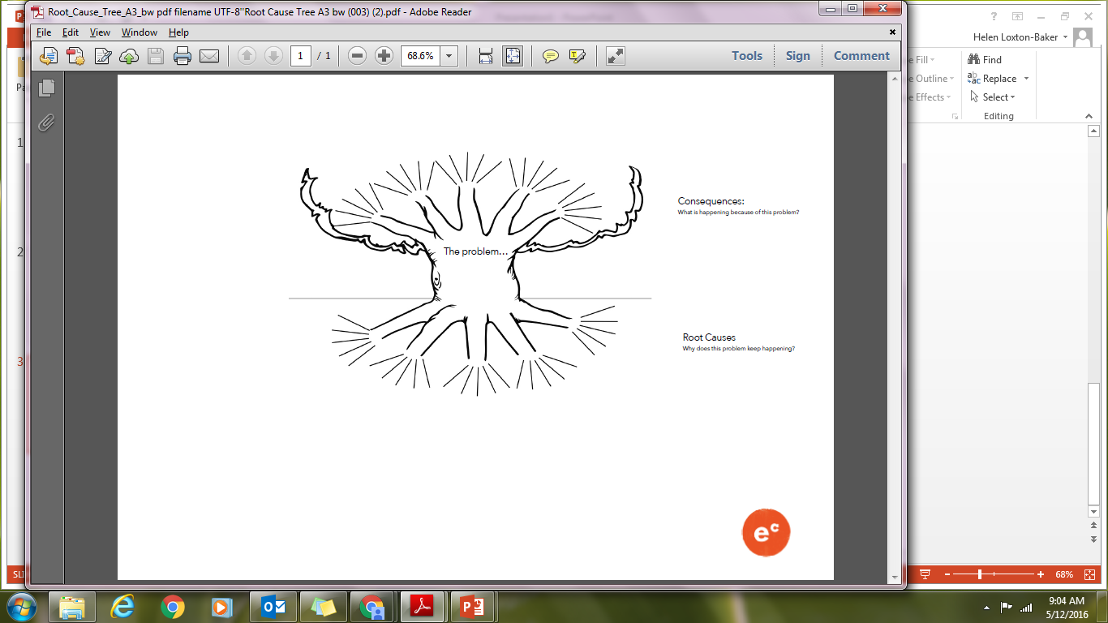

**The Montgomery Bus Boycott**

Root Causes?

Why was there a bus boycott in Montgomery in 1955?

Consequences?

What are the main results of the Boycott?