Role of governments in Civil Rights Movements in the USA

US President | Key Civil Rights Events | Examples of Government Action | Other factors that led to changes in civil rights
Franklin Roosevelt
1933-45
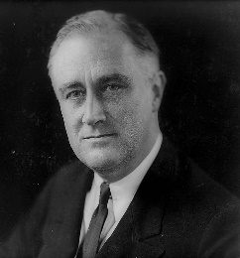
Truman
1945-53
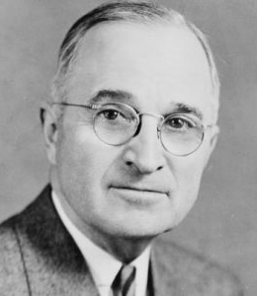
Eisenhower
1953-61
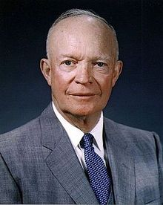
Kennedy
1961-63
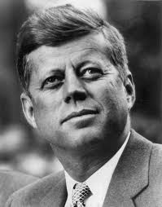
Johnson
1963-69
